UNIT 2ND

1. STRESSEN MATRIX MULTIPLICATION :

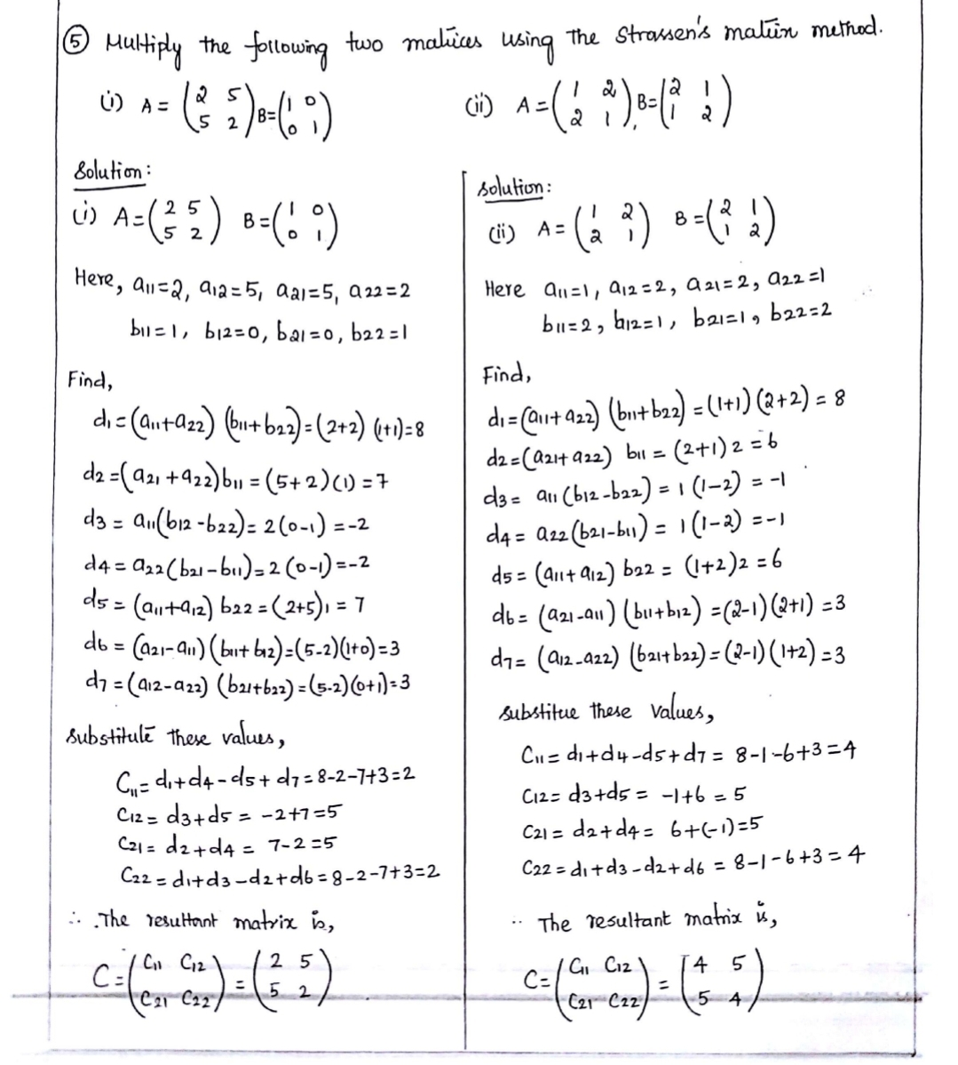

1. MINIMUM AND MAXIMUM OF ARRAY

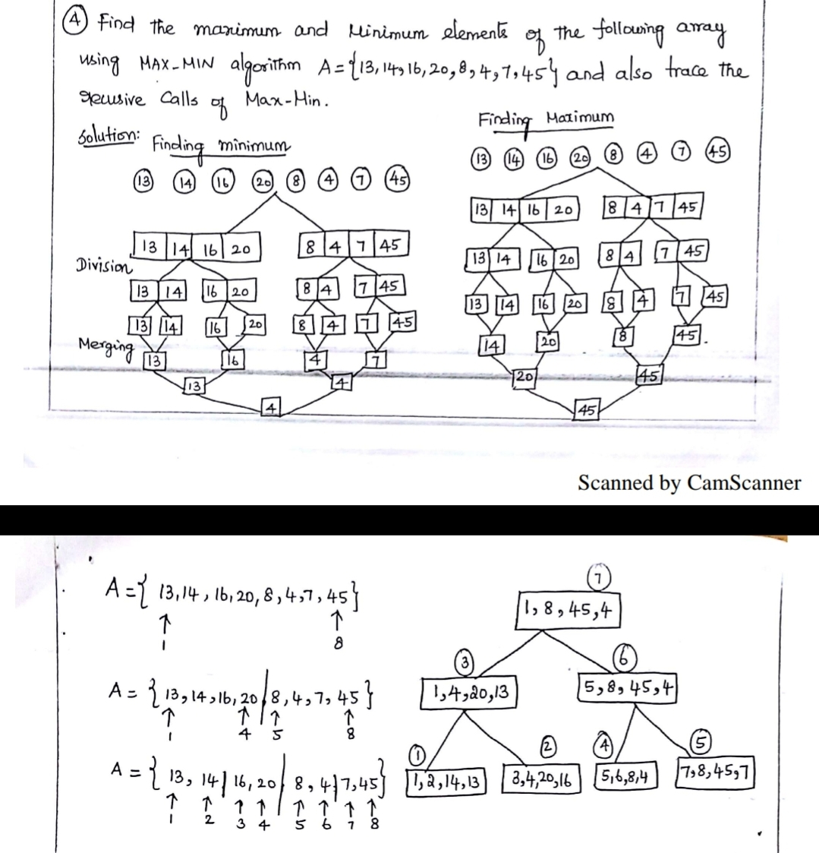

3.QUICK SORT

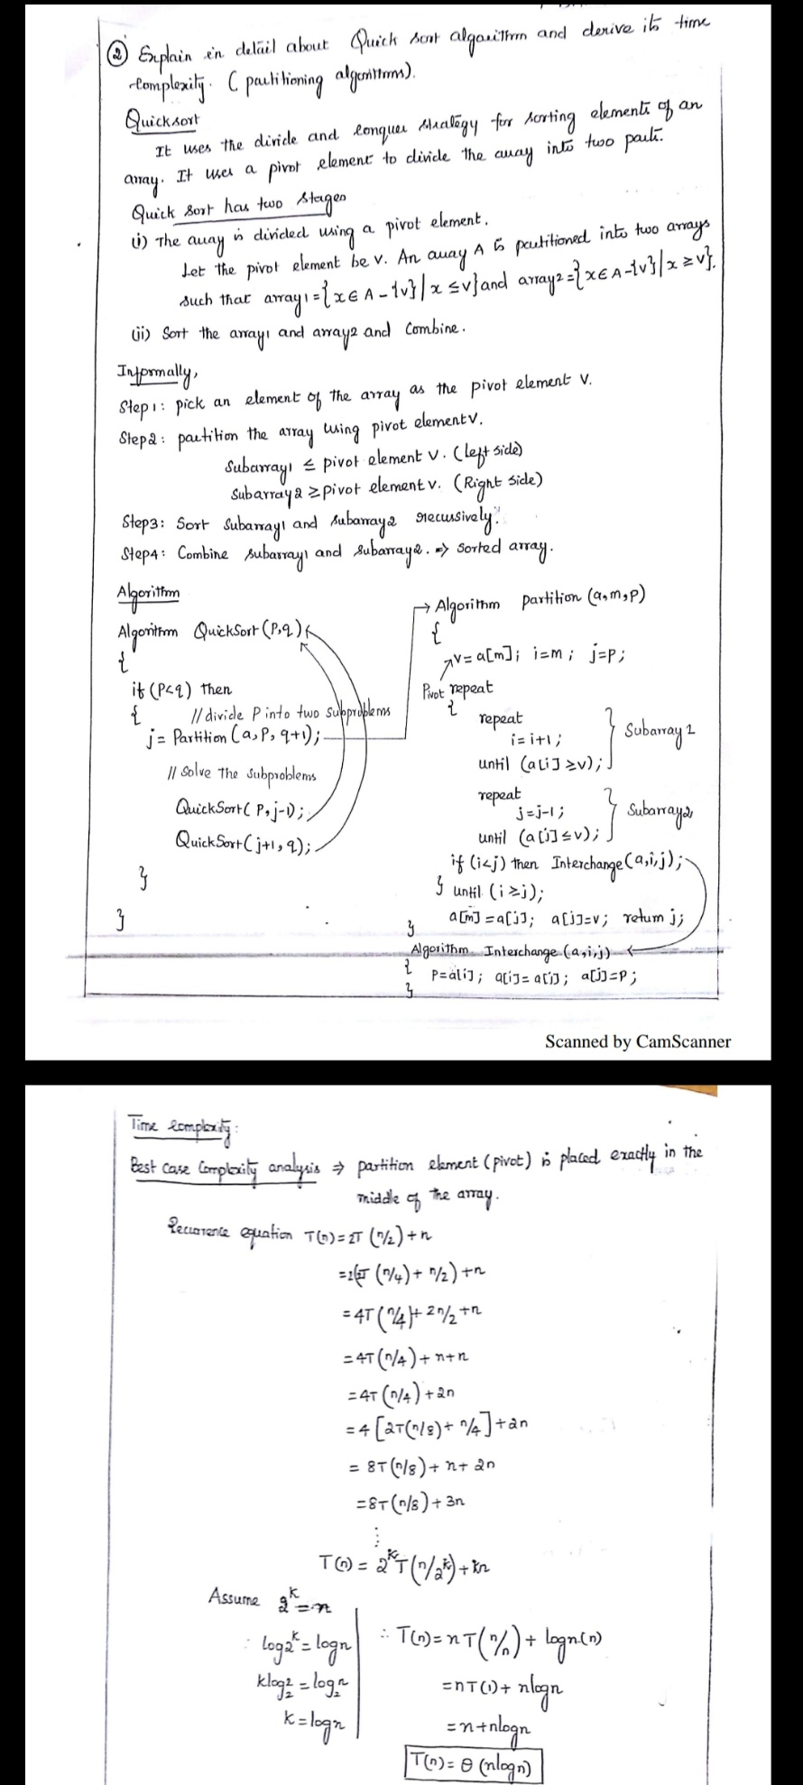

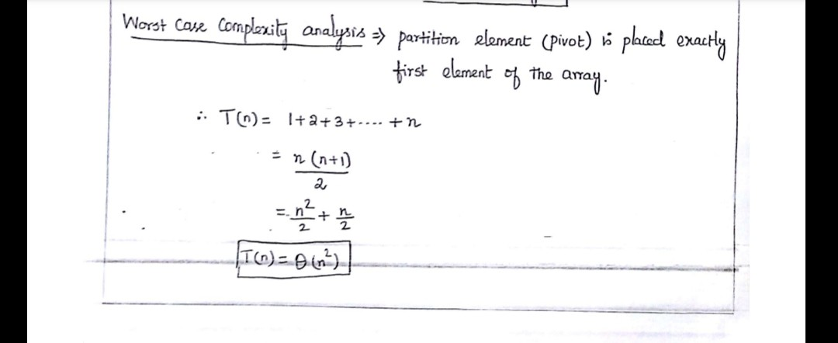

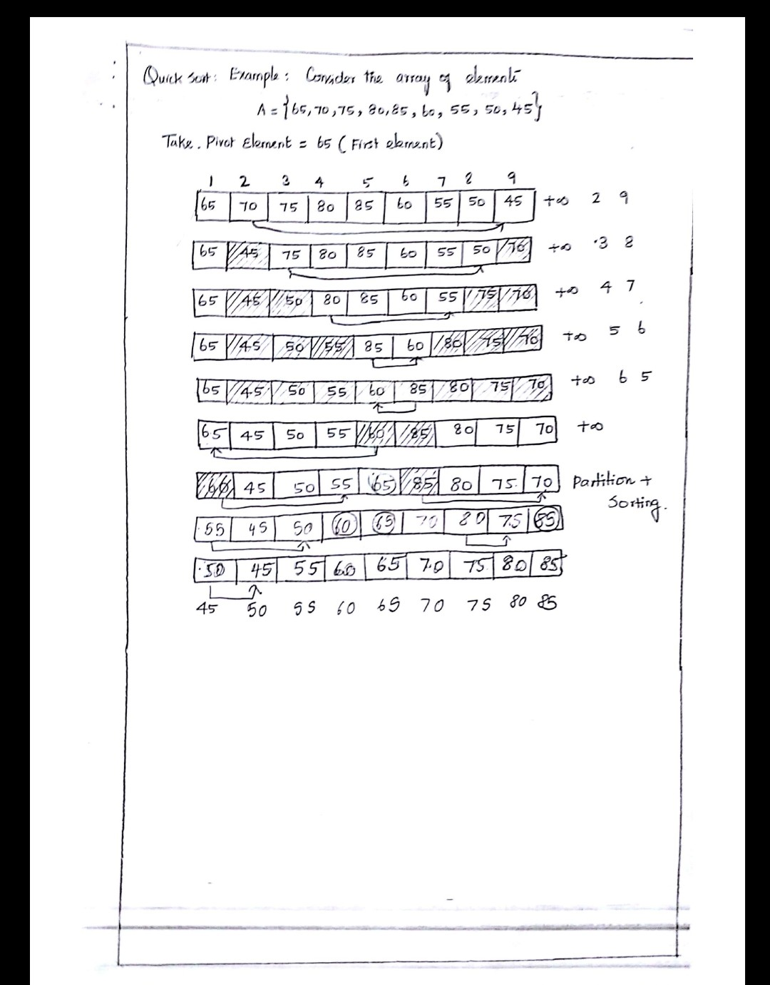

4.MASTER THEOREM:

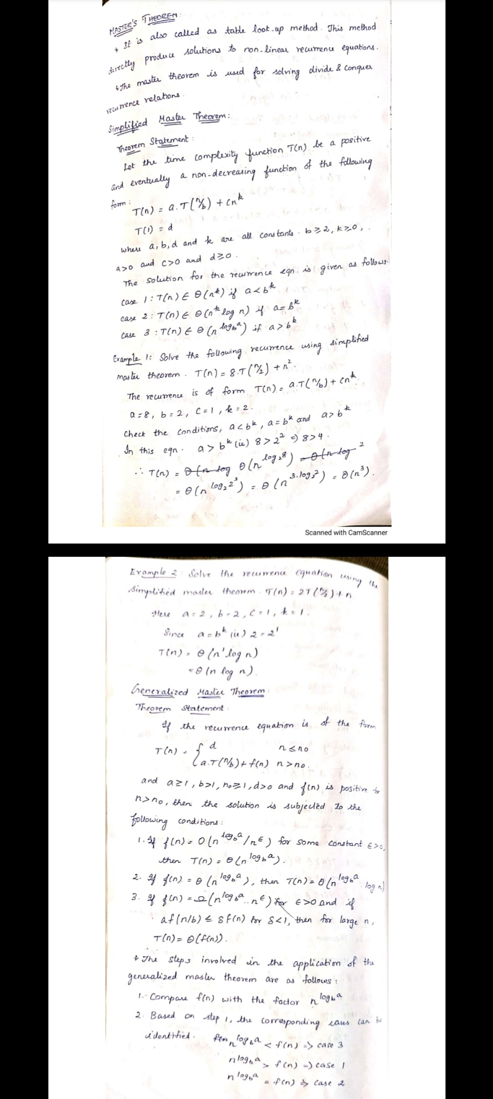

UNIT 3RD

1. KNAPSACK PROBLEM

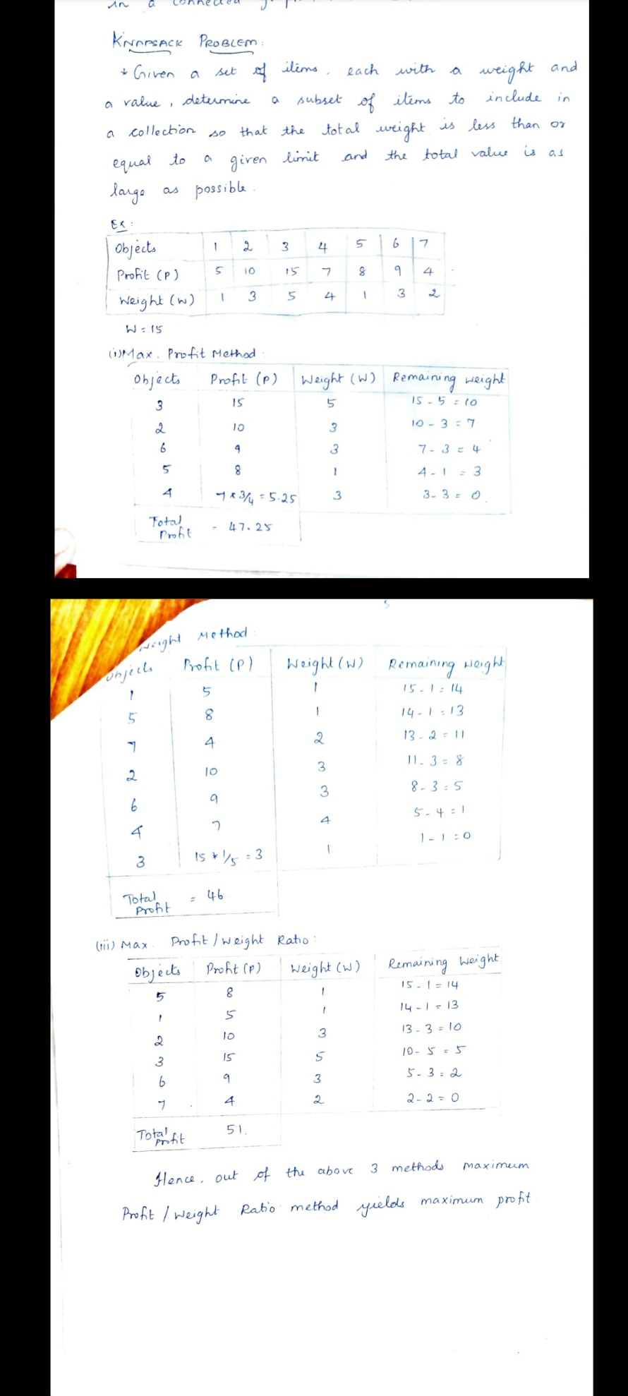

1. HUFFMAN CODING

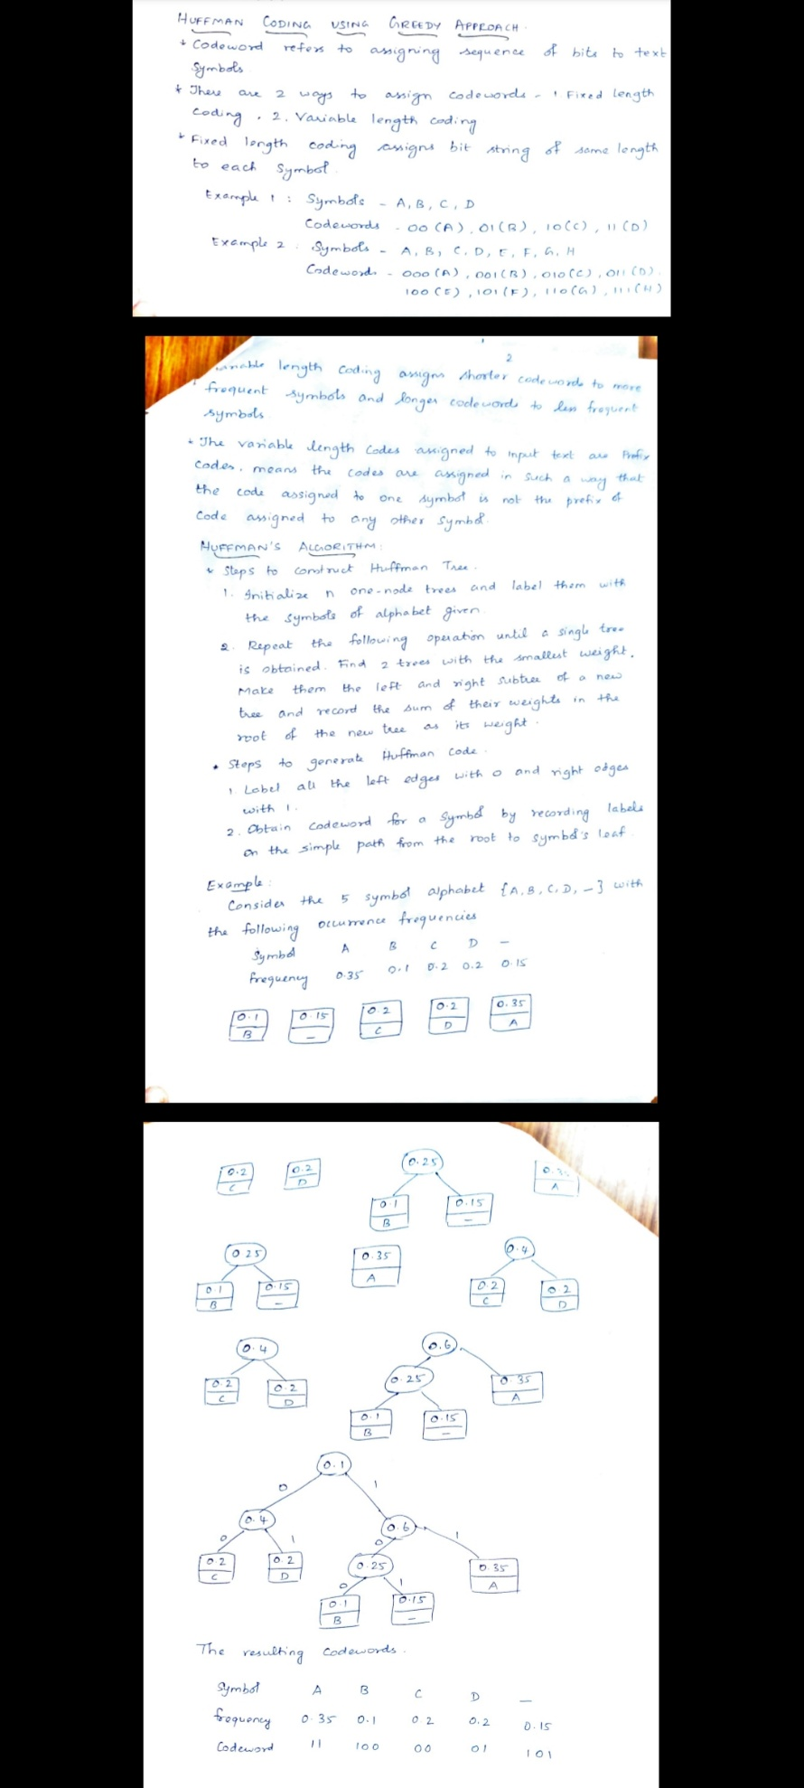

1. MINIMUM SPINNING TREE

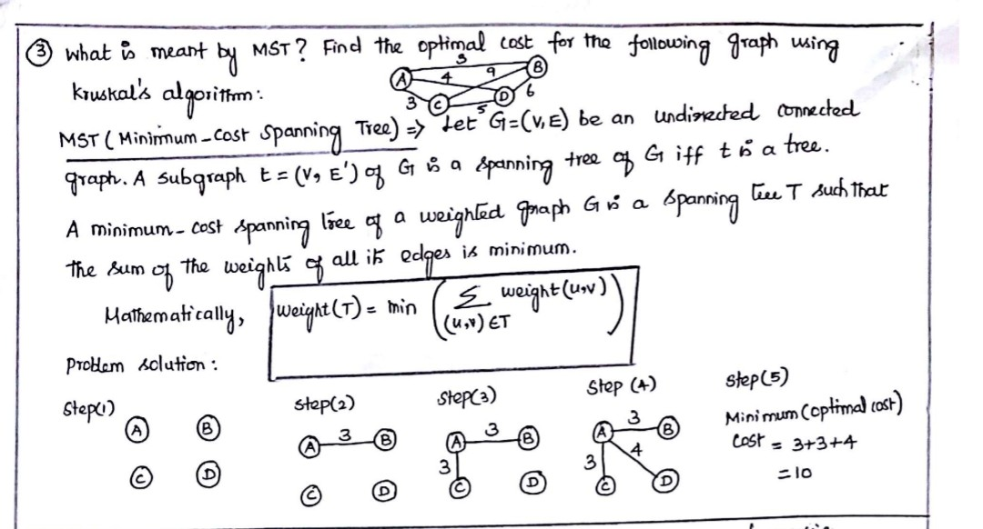

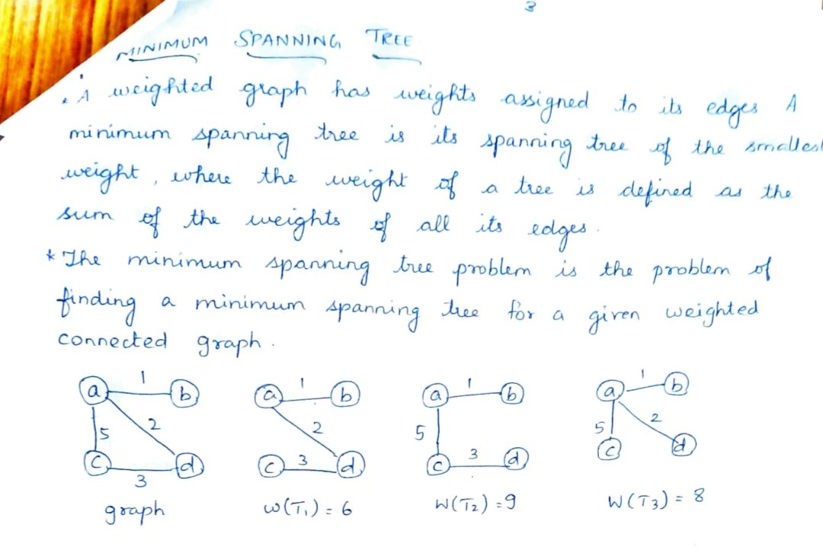

1. OPTIMAL BINARY SEARCH

TAKE HELP FROM GOOGLE**🙂**